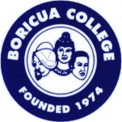
Boricua College

A TRADITION OF LEARNING

Boricua College (BC) is a private not-for-profit four-year college chartered by the New York State Board of Regents to grant associate, bachelors, and master degrees with programs authorized by the New York State Education Department. Boricua College is an accredited institution and a member of the Middle States Commission on Higher Education (MSCHE).

MSCHE is an institutional accrediting agency recognized by the U.S. Secretary of Education and the Council for Higher Education Accreditation (CHEA).

The Commission’s most recent action on Boricua College’s accreditation status on June 24, 2022 is Non-Compliance Warning. Boricua College remains accredited while on warning and its Statement of Accreditation is maintained as noted on the MSCHE website.

Boricua College continues as a member in good standing of organizations dedicated to higher education including, NY State Commission on Independent Colleges and Universities, Association of Governing Board of Universities and Colleges, Hispanic | 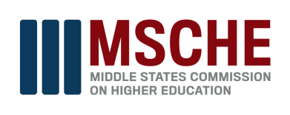
Association of Colleges and Universities, National Association of Independent Colleges and Universities, National Association of Student Financial Aid Administrators and Association for Advancing Quality in Educator Preparation.

